International Journal of Darshan Institute on ENGINEERING Research AND EMERGING Technologies
Vol. x, No. x, 20xx
www.ijdieret.in
IJDI-ERET

(Type of Article e.g. Research Article, Review Article etc.)
Guidelines for Preparing and Writing the Paper for IJDI-ERET

D. D. Vyas^{1*}, A. J. Tankariya², R. G. Dhamsaniya³

^{1*,2}Department of Electronics & Communication Engineering, Darshan Institute of Engineering & Technology Rajkot, Gujarat, INDIA
³Department of Civil Engineering, Darshan Institute of Engineering & Technology Rajkot, Gujarat, INDIA

Abstract

The guidelines for preparing final papers, for International Journal of Darshan Institute on Engineering Research and Emerging Technologies have been presented. This file can be used as a template for preparing the final manuscript after acceptance. This document also provides guideline for preparing the manuscript. The manuscript should start with appropriate and concise title with detail of type of article e.g. Research Article (please refer aim and scope of the Journal). An abstract is a concise single paragraph text of the work. In a minute or less a reader can learn the rationale behind the study, general approach to the problem, pertinent results, and important conclusions or new questions. Write your abstract after the rest of the paper is completed. Economy of words is important throughout any paper, but especially in an abstract. However, use complete sentences and do not sacrifice readability for brevity. You can keep it concise by wording sentences so that they serve more than one purpose. It has limited background information to a sentence or two, if absolutely necessary. It is always written in past tense. Do not cite references in the abstract. For effective abstract, there should be 50-200 words in the abstract.

Keywords: Four to six keywords are to be provided for indexing purposes.

1. Introduction

Publication of articles in professional journals, which publishes papers for specialists and do not ordinarily pay for contributions, may benefit a person in many ways. Such publications are likely to increase career advancement, to increase your circle of your professional acquaintances, to get feedback of your ideas, etc. Usually papers submitted to the journals are very large and many a times they are either rejected or returned with a request for major/ minor revisions. A paper is turned down for a number of reasons, which is not only due to the quality of work but also due to the quality of presentation. Although quality of work and presentation are equally important [1].

The introduction is the first paragraph of the paper. It often begins with a general statement about the topic and ends with a more specific statement of the main idea of your paper. The purpose of an introduction is to acquaint the reader with the rationale behind the work, with the intention of defending it. It places your work in a theoretical context, and enables the reader to understand and appreciate your objectives. The body of the paper follows the introduction. It consists of a number of paragraphs in which you develop your ideas in detail.
  - Limit each paragraph to one main idea. (Don't try to talk about more than one idea per paragraph.)
  - Prove your points continually by using specific examples and quotations from your note cards.
  - Use better transitional words to ensure a smooth flow of ideas from paragraph to paragraph.

The introduction should be brief relative to the rest of the paper. If the opening is inappropriately lengthy, the reader will lose interest, annoyed that you have failed to get started. Do not include unnecessary background information, especially if the community is already conversant with the material on which you are writing. Your introductions should not exceed two pages. The purpose of the introduction is to:

  - Let the reader know what the topic is
  - Inform the reader about your point of view
  - Arouse the reader's curiosity so that he or she will want to read about your topic.
  - To engage the reader's attention
  - To identify for the reader the central issue or subject

Approaches vary widely, however the following approach can produce an effective introduction.
*Corresponding Author: e-mail: vyasdd.diet@gmail.com,
Tel-+91-97277 47318, +91-97277-47310
ISSN 2320-7590 (Print) 2583-3863 (Online)
© 2023 Darshan Institute of Engg. & Tech., All rights reserved
  - Describe the importance (significance) of the work - why was this worth doing in the first place? Provide a broad context.
  - Defend the model - why did you use this particular organism or system? What are its advantages? You might comment on its suitability from a theoretical point of view as well as indicate practical reasons for using it.
  - Provide a rationale. State your specific hypothesis (es) or objective(s), and describe the reasoning that led you to select them.
  - Very briefly describe the experimental design and how it accomplished the stated objectives.
  - Use past tense except when referring to established facts. After all, the paper will be submitted after all of the work is completed.
  - As always, pay attention to spelling, clarity and appropriateness of sentences and phrases.

2. Body of Manuscript

A conventional way to plan a manuscript is to construct an outline. An outline has two interacting purposes. One is to shape the technical information in logical order and other is to help in organizing and thinking about paper. It should be flexible. The main text should be divided into several sections and subsection. There should be continuity in the presentation. The style of sections and subsection are generally given in the guidelines of the journal. If nothing is available, it is preferable to see the previous issue of the journal concerned. The complex mathematical derivation should be placed in the appendix of the paper, which is placed at end of the paper.

2.1 Sections and subsections: The structure of main sections can be built in a ways that strengthen the concept of manuscript. The first of these supporting methods is the adoption of good, descriptive headings of sections and subsections. The choice if these headings are important because well-chosen headings are not only an aid to the reader but also a reminder to the author(s) to keep in focus the content of each section. Illustrations and tables enhance the quality of presentation.

2.2 Copyright form: A copyright form should accompany your final submission. The copyright form will be provided by the editor after final acceptance of the paper. Authors are responsible for obtaining any security clearances.

2.3 Useful information: Some of the information are available with the editors and thus those are to be written as xx such as volume number of the journal, page numbers etc. Use either SI (MKS) as primary units.

2.4 References: References are important to the reader; therefore, each citation must be complete and correct. References should be readily available publications. In the text, references should be numbered consecutively at the time they first appear and should be given in brackets (e.g. [1]; [2],[3] or [4 - 6]).

2.5 Biographical notes: Mention brief bio-data of all authors with appropriate size photograph.

2.6 Margins and Paper size: As per the requirement of printing margins and paper size are set in the template. Follow the mirror margins and paper size of letter i.e. 8.5” x 11”, in your manuscript as per the template.

3. Table Figures and Equations

Continue to be concise, using figures and tables, if appropriate, to present results most effectively. See recommendations for content, below. You must clearly distinguish material that would normally be included in a research article from any raw data or other appendix material that would not be published. In fact, such material should not be submitted at all unless requested by the instructor.

  - Summarize your findings in text and illustrate them, if appropriate, with figures and tables.
  - Describe results of control experiments and include observations that are not presented in a formal figure or table, if appropriate.
  - Analyze your data, then prepare the analyzed (converted) data in the form of a figure (graph), table, or in text form.

3.1 Figures and tables: Because IJDI-ERET will not do the final formatting of your paper, you need to position figures and tables at the top and bottom of page and close to where they are refereed in the text. Insert figure as an image and do not import it directly from other application. Place figure captions below the figures; place table titles above the tables. If your figure has two parts, include the labels “(a)” and “(b)” as part of the artwork. Figure captions should not be part of the figure but written separately as text. Please verify that the figures and tables you mention in the text actually exist. In text, refer to each figure as "Figure 1," "Figure 2," etc.; number your tables as well.

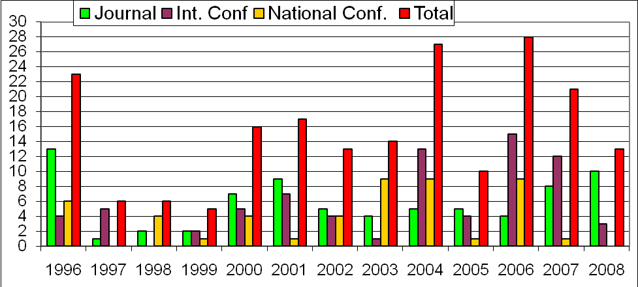
Figure 1. Publication of author

As journal papers are generally printed in black and white it is advisable that where ever possible the figures should be given in gray scale. After inserting the figures verify its readability by converting it to formats generally used for printing eg pdf.
Do not abbreviate “Table.” Tables are numbered with numerals. Regardless of placement, each table must be titled, numbered consecutively and complete with heading. Table 1 shows the fonts and style for the paper. Complete text all over the paper should be using Times New Roman fonts. Publication of author-1 is shown in Figure 1.

Table 1. Fonts, style and appearance
Point size | Purpose in paper | Remarks
18 | Title | Title should be in sentence case and in bold font
12 | Author’s name | It should be in bold font
10 | Sections | Sections should be in sentence case and in bold font
10 | Body text, equations, table caption, figure captions
10 | subsections | subsections should be in sentence case and in italics
8 | Affiliation of authors

3.2 Equations: Do not copy equations type it. If you are using Word, use either the Microsoft Equation Editor or the MathType add-on for equations in your paper. Number equations consecutively with equation numbers in parentheses flush with the right margin, as in (1). Use parentheses to avoid ambiguities in denominators. Punctuate equations when they are part of a sentence, as in

(1)

4. Conclusions

Although a conclusion may review the main points of the paper, do not replicate the abstract as the conclusion. A conclusion might elaborate on the importance of the work or suggest applications and extensions. Functions of a concluding paragraph are:

  - To make one last effort to convince the reader
  - To suggest larger implications now that the evidence has been presented
  - To provide a satisfying sense of closure

Strategies for writing effective conclusions are:

  - Make a useful analogy or comparison.
  - Suggest specific actions that the reader should take in light of the information you've provided.
  - Speculate about what your thesis implies for the future.
  - Make a brief remark that sums up your feelings.

Nomenclature

IJDI-ERET - International Journal of Darshan Institute on Engineering Research and Emerging Technologies
C_{s} - Saturation concentration of dissolved oxygen in water (mg/L).
C_{t} - Concentration of dissolved oxygen in water at any time ‘t’.

Appendix

Appendixes, if needed, appear before the acknowledgment. Nomenclature, appendix, acknowledgement and references are not numbered.

Acknowledgement

Acknowledgement is placed before the references. It is not the compulsory part of the paper. If the work presented in the paper has significant contribution from agencies/persons other than the authors then only refer it in acknowledgement.

References

- Singh S.N. and Tripathi N.K., Writing and Publishing a Research Paper in Professional Journals: A Systematic Approach, Asian Journal of Geoinformatics, Vol. 1, No. 3, pp. 87-90, 2001.
- Abusam.A., Keesman K.J., Spanjers H., Straten G. and Meinema. K., Effect of oxidation ditch horizontal velocity on the nitrogen removal process. European Water Management Online, EWA 2002.
- Metcalf and Eddy Inc., Waste water Engineering; Treatment disposal and reuse. 3rd ed. Tata McGraw Hill, New Delhi India, 1200p, 2001.
- APHA, Standard methods for the examination of water and wastewater, 15th Ed., American Public Health Association, America Water Works Association, and Water Pollution Control Federation, Washington D.C., 1985.
- Eckenfelder W.W., Process design of aeration system for biological waste treatment. Chemical. Engineering Progress, Vol.52, No 7, pp. 286-292, 1956.
- Zlokarnik M., Scale up of surface aerators for waste water treatment. Advance Biochemical Engineering, Vol.11, pp.157-179, 1979.
- Thakre S.B., Bhuyar L.B. and Deshmukh S.J., Oxidation ditch process using curved blade as aerator. International Journal of Environmental Engineering, Science and Technology, Vol.6. No.1, pp.113-122, 2009.
- M. Watson, Using the PowerLoom Reasoning System with JRuby, http://markwatson.com/aiblog., 2007.
- M. Nichols, The Graphical Kernel System in Prolog, Master’s thesis, Dept. Computer Science and Eng., Indian Inst. of Tech., Bombay, 1999.

Biographical notes

formal  Photograph | D. D. Vyas has received his Ph.D. from Saurashtra University in Electronics and Communication Engineering and M.Tech. from IIT, Bombay in Electronic Systems. He is Professor and Head of Department Electronics & Communication department of Darshan Institute of Engineering & Technology, Rajkot, Gujarat, India. His research interest includes Embedded Systems, Industrial automation, Control and Digital Signal Processing.
formal  Photograph | A. J. Tankariya has received M.Tech. in VLSI Design from Rajiv Gandhi Proudyogiki Vishwavidyalaya University, Madhya Pradesh in 2012. He is working as an Assistant Professor in Department of Electronics & Communication of Darshan Institute of Engineering & Technology, Rajkot, Gujarat, India. His are of interest includes VLSI technology and Communication System.
formal  Photograph | R. G. Dhamsaniya has received Ph.D. and M.E. in Structural Engineering from S.P.University He is Professor in Civil engineering department at Darshan Institute of Engineering & Technology, Rajkot, Gujarat, India

Note: Remove this happy face and put your photograph at its place with square text wrapping.

